BBYC - MVC Assesment



# Objective

Your objective is to create a single page web app containing the following:

* Product listings as the main focus
* Single level category listing side bar
* Modal window for displaying more detailed product information (Image, Title and short description is good enough).
* Unit tests and functional tests

**Initial view**: All Top level categories are shown and all products are shown (limited to 32 by default from API)  
**On category click**: Show only products to selected category (limited to 32 by default from API)

The assessment must use only client side code – there is no need to create any server-side code. You will use Best Buy Canada’s REST API for data (see page 2 for URLs).

You are not permitted to use a JavaScript framework to complete this assessment (with the exception of testing frameworks) however you can make use of third-party libraries for AJAX, dependency management, and a build process (optional). Template engines are also allowed, and encouraged.

The purpose of this exercise is to get an idea of your ability to implement design patterns where appropriate, with regards to a high-traffic website. In particular we are looking for an object-oriented approach comprised of extensible, decoupled, and tested modules/components. You are encouraged to include explanations regarding the design decisions you made.

Styling is not required and you will be judged on functionality, not presentation. You may use a CSS framework and/or grid system of your choice if you so desire.

# Wireframe

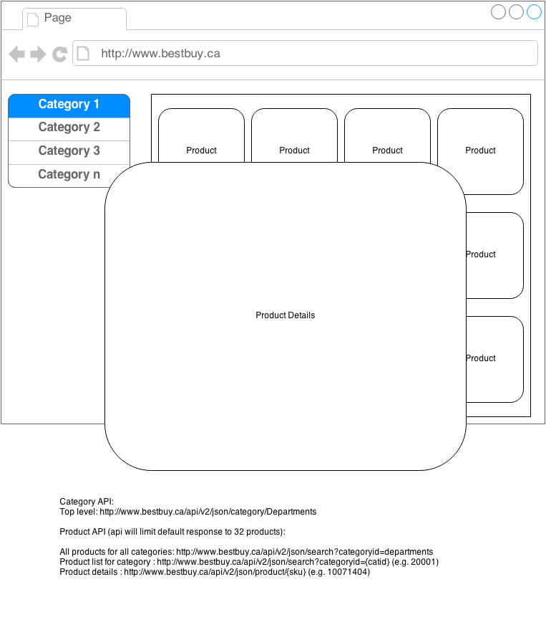

Please send your app files as a **GitHub repo** to the following email addresses: [idouglas@ignitetechnical.com](mailto:idouglas@ignitetechnical.com) and [agontcharov@ignitetechnical.com](mailto:agontcharov@ignitetechnical.com)

Good luck!